**USING ARCHICAD**

**FLOOR PLAN**

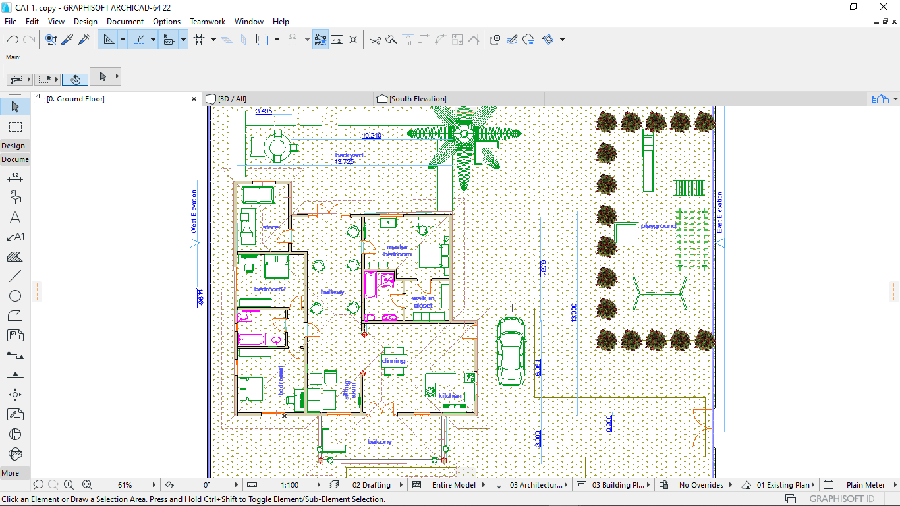

**3D PLAN**

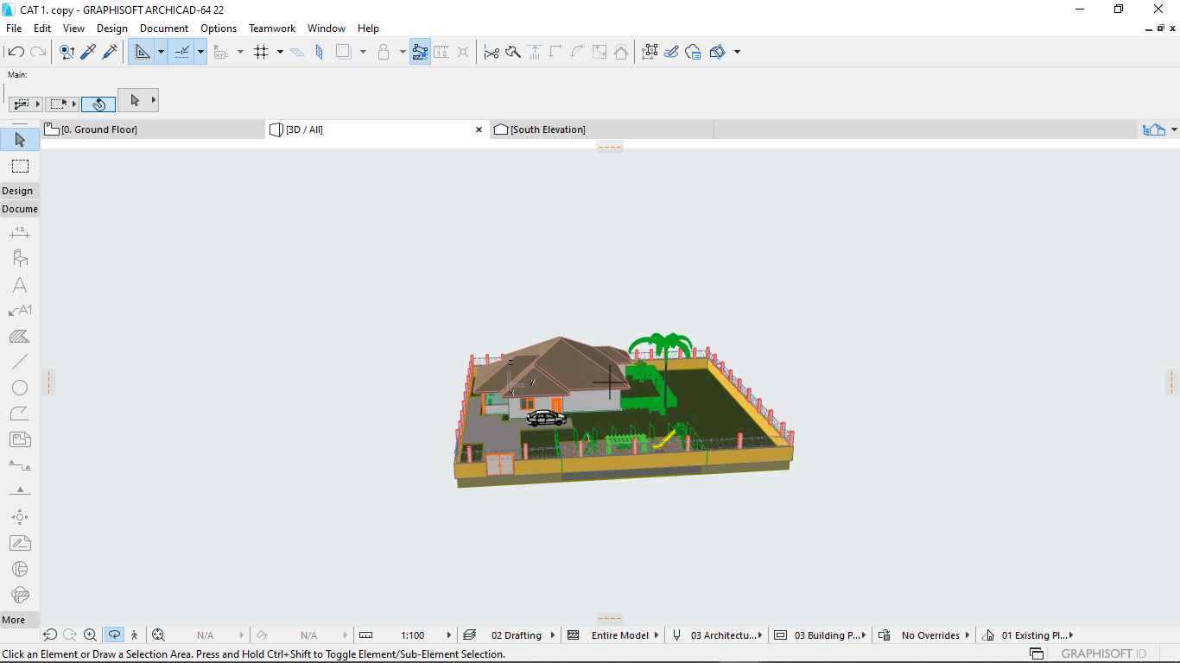

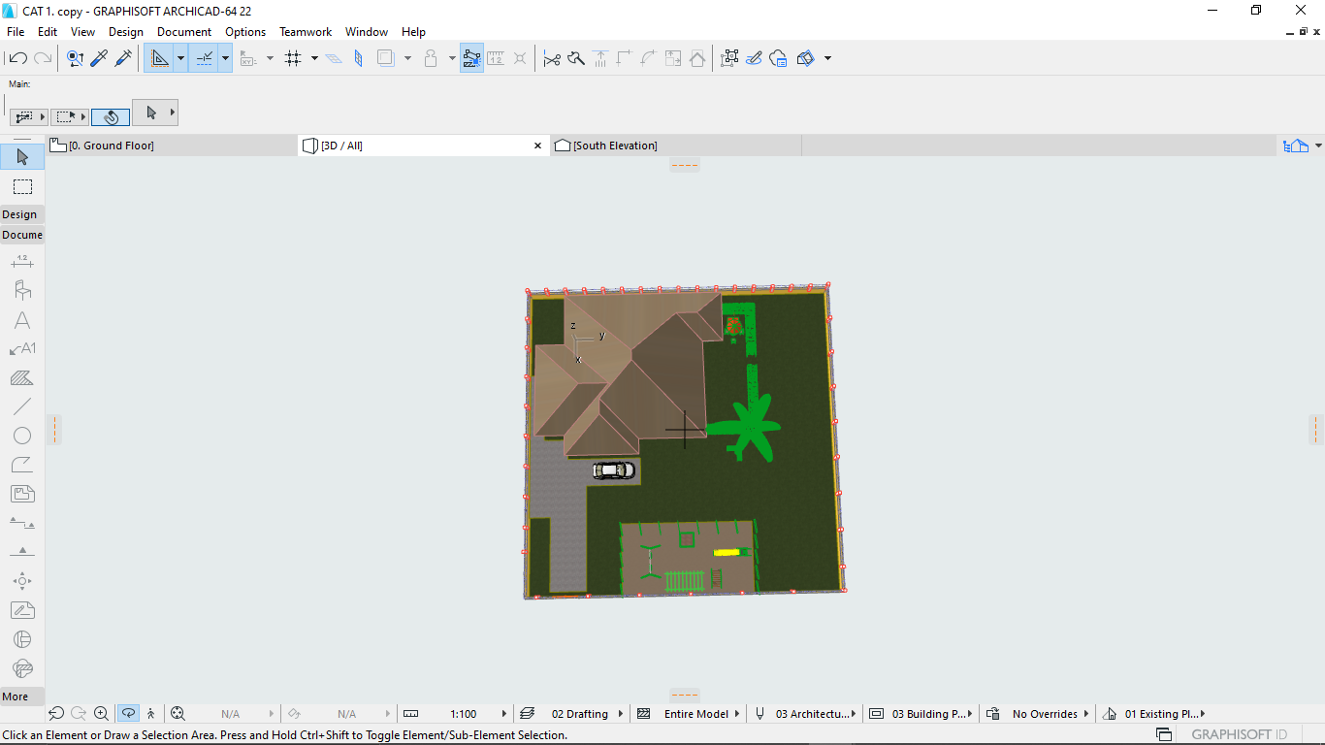

**VIEWS IN DIFFERENT ELEVATIONS**

**I)North Elevation**

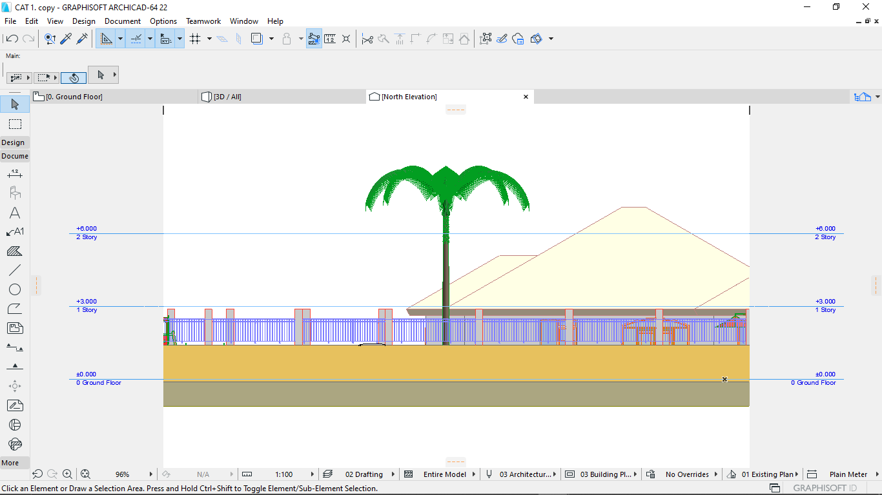

**II)South Elevation**

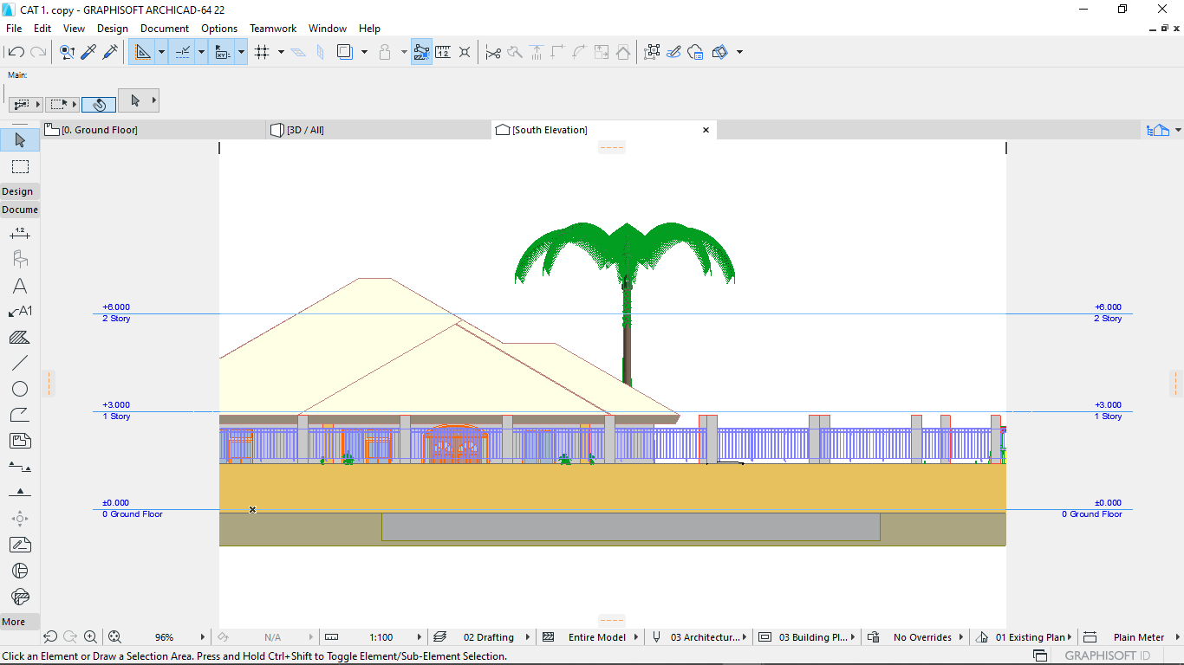

**III)East Elevation**

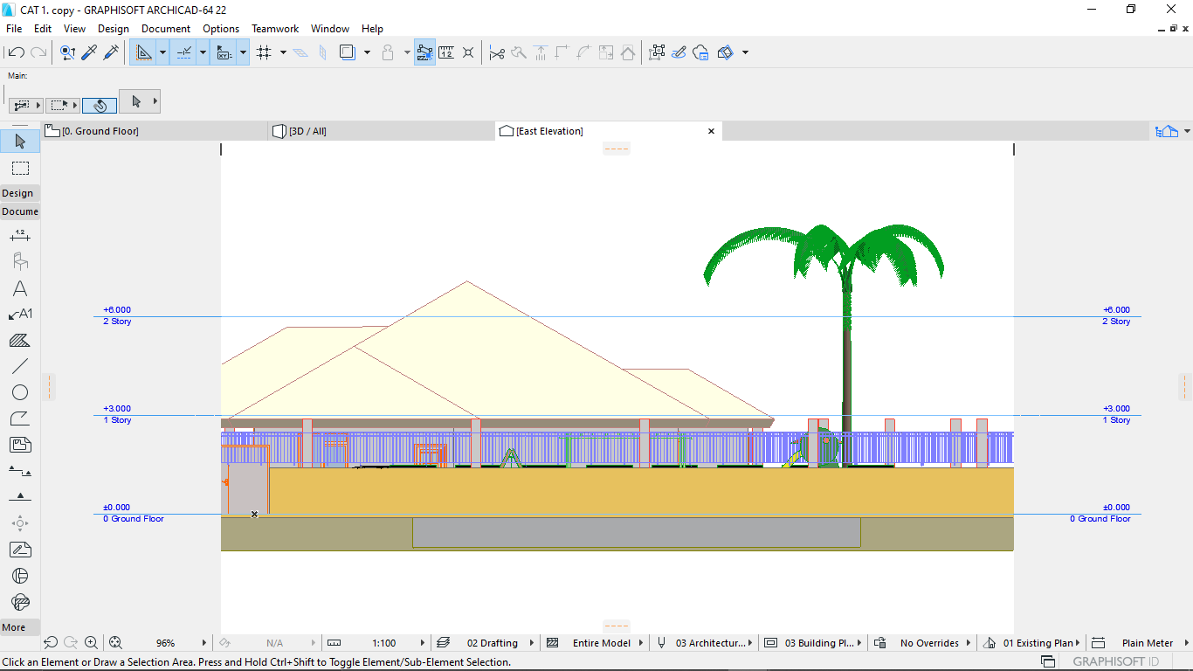

**IV)West Elevation**

